Course Methods Year 11 Test 2

Student name: ________________ Teacher name: ________________

Task type: Response

Time allowed for this task: 40 mins

Number of questions: 5

Materials required: Formula Sheet and 1 page both sides of notes permitted.
No Calculators allowed.

Standard items: Pens (blue/black preferred), pencils (including coloured), sharpener, correction fluid/tape, eraser, ruler, highlighters

Special items: Drawing instruments.

Marks available: 38 marks

Task weighting: 10 %

Formula sheet provided: Yes

Note: All part questions worth more than 2 marks require working to obtain full marks.

- (1.1.10-1.1.11) (3, 2, 2, 4 = 11 marks)

(a) Part of the graph of is shown below.

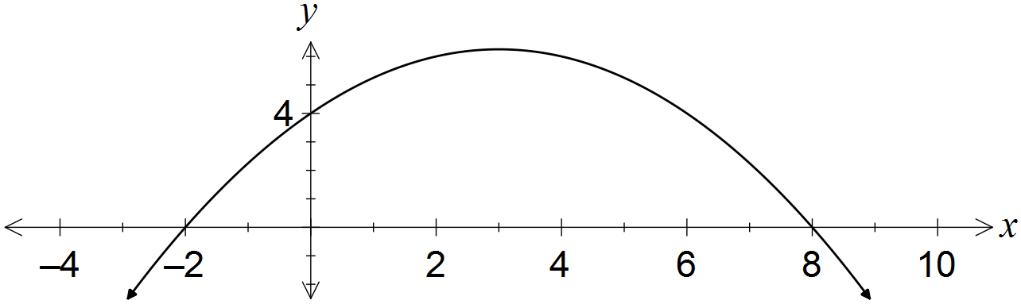

Determine the values of the coefficients a and b. (3 marks)

(b) A quadratic has equation . Determine

(i) the coordinates of its turning point. (2 marks)

(ii) the exact values of the zeros of the quadratic. (2 marks)

(c) Show if it is possible to bend a 12 cm length of wire to form the perpendicular sides of a right angled triangle with area 20cm? (4 marks)

Question 2 (1.1.21, 1.1.22) (2, 1, 3, 3 = 9 marks)
(a) A circle of radius 5 has its centre at (6, -4).

(i) Determine the equation of this circle. (2 marks)

(ii) State, with justification, whether the point (9, -8) lies on the circle. (1 mark)

(b) Determine the centre and radius of the circle with equation .
(3 marks)

(c) Find the equation of the curve drawn below. (3 marks)
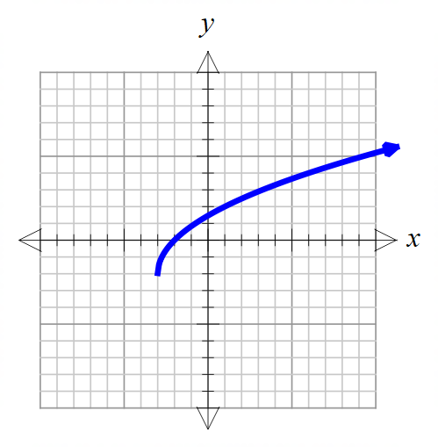

(-3,-2)
(6,4)
Question 3 (1.1.14) (2, 2, 2 = 6 marks)
A rectangular hyperbola has asymptotes with equation $x=-2$ and $y=4$.
- Write two possible equations for this function

- Write the equation of this function if it has a y-intercept at (0,5)

- Write the equation of this function if it passes through the point (3,5)

Question 4 (1.1.24) (1, 2, 1, 2 = 6 marks)
- Given $f\left(x\right)=x^{2}-2x$

- What type of correspondence does $f$ show? Circle one of the following.

Many-to-one One-to-many One-to-one

- If the domain of $f$is $f\left(x\right)∈R, -4≤x≤5$, find the range of $f.$

- Given $y=2+\sqrt{4-x^{2}}$

- What is the largest possible value of $y$.

- Determine the domain and range.

Question 5 (1.1.24) (1, 1, 2, 2 = 6 marks)
Suppose $G\left(x\right)=\frac{2x-3}{x-4}$.

- Evaluate $G\left(2\right)$

- Find a value of x such that $G\left(x\right)$ does not exist.

- Find $G(x+2)$ in simplest form.

- Find x such that $G\left(x\right)= -3.$

